FIVE TEACHING POINTS OF NEO-CALVINISM
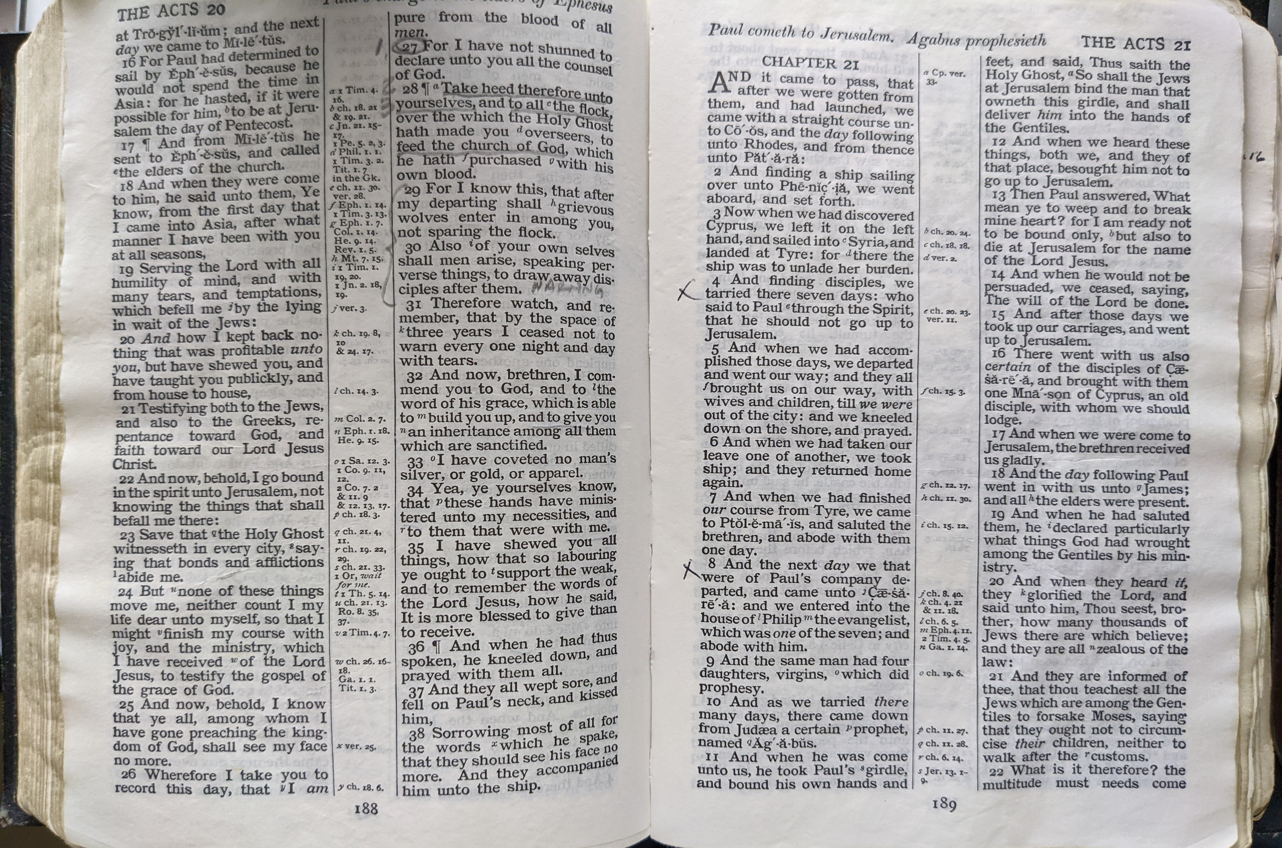
  - Compared To God’s Word
Dates, Times, Topics and Speakers:
October 3, 2025- 7:30 PM Name: Darrell Trammel from the Oaks West congregation in Burnet, TX
1. Man's inability to resist sin, understand scripture, or choose faith without a direct operation of the Holy Spirit.

October 10, 2025- 7:30 PM Name: George Slover from the Hunter Rd. congregation in San Marcos, TX
2. The imputation or transfer of the personal righteousness of Jesus or the personal goodness of God to the believer. And (two topics)…. 3. Faith defined as non-doing trust.

October 17, 2025- 7:30 PM Name: Jacob Hudgins from the Twin City congregation in College Station, TX
4. A Christian's sins are automatically and continuously cleansed by the blood of Christ.

October 24, 2025- 7:30 PM Name: Mike Gentry from the Leon Valley congregation in Temple, TX
5. The Gospel-Doctrine distinction (a radical de-emphasis of the New Testament Epistles)
This series is being held at:
South Loop church of Christ
303 Carlos Parker Blvd. SE
Taylor, TX
No collection taken at these assemblies

